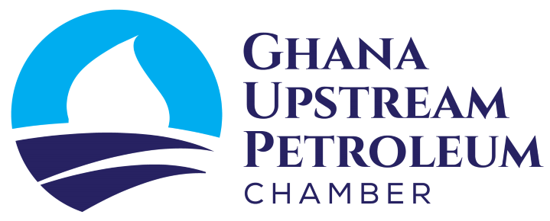
PRESS

RELEASE
Accra, 21st March 2023

Reconsider Growth and Sustainability Levy

The introduction of a growth and sustainability levy by the government could not have come at a worse time when the country is struggling to attract new investments in oil and gas exploration. The provision for a 1% tax on gross production for oil and gas companies, represents an increase in royalty to all intents and purposes. There is also a 5% tax on profit before tax that applies to the oil and gas service companies meaning taxes will be imposed irrespective of the financial performance of the target business.

Introducing additional taxes at a time when the industry is going through challenging times is rather unfortunate, anti-business, risks the collapse of indigenous oil service companies and could trigger disinvestment by IOCs.

The industry considers this levy as the latest in a series of creeping taxation that is affecting the economic balance of petroleum agreements. Other examples of creeping taxation include the COVID-19 Recovery Levy, Ghana Education Trust Fund Levy, National Insurance Levy, the 1% local content fund levy and several others.

Rather than breach provisions of Petroleum Agreements to raise money from creeping taxation, which could trigger litigation through the international courts, we urge the government to pursue a path of reserves and revenue growth through expedited award of exploration blocks to prospective investors.

This new tax disregards the importance of the preservation of contract sanctity to the promotion of new investment. Unpredictability of the fiscal terms of our petroleum agreements will disincentivize new oil and gas investment at a time when financial institutions are curtailing investment in fossil fuels.
“This Growth and Sustainability Levy will damage investments", commented Joe Mensah, Senior Vice President of Kosmos Energy Ghana, and Chairman of the Upstream Chamber. In his comments on the issue, the CEO of the Upstream Petroleum Chamber, David Ampofo, said "this new tax is an increase in royalties in disguise and an imposition that will inhibit further the growth of our service companies”.

The lack of stability and predictability on a matter as important as tax, means businesses cannot even be sure what their investment returns are likely to be. It is in Ghana’s continued interest to encourage exploration and development of its hydrocarbon reserves by attracting foreign capital, but there are taxation impediments that need addressing, and creeping taxes such as this are an example. When creeping taxes and levies become the norm, tax avoidance and disinvestment become inevitable. We therefore urge government to reconsider the Bill and send a positive signal to the market.

Industry is ready to join hands with other affected parties to engage government on this matter.

About the Chamber
The Upstream Chamber represents the shared interests of companies involved in oil and gas exploration and production as well as oil field services in the country. The Chamber promotes, enhances and facilitates the growth of the industry through networking, education, industry information and advocacy for a favourable business environment. As the voice of the industry, the Chamber provides advocacy services to its members and helps them navigate the regulatory framework.
The Chamber also offers a platform through which the industry can be reached by stakeholders from across the economy, including local communities.

