THE TIME FOR CLIMATE ACTION IS NOW - IPCC
The Intergovernmental Panel on Climate Change (IPCC) published its third assessment report, on 4th April 2022, which focuses on the Mitigation of Climate Change. The summary of the report was approved by all 195-member governments of the IPCC thus marking the third instalment of four instalments of the IPCC Sixth Assessment Report (AR6) cycle. The report hammers on the statement that “The evidence is clear: The time for action is now.”
United Nations Environmental Programme (UNEP) together with the World Meteorological Organization (WMO) formed the Intergovernmental Panel on Climate Change (IPCC). Since its inception in 1988, the institution has been designed to share a well-defined and scientific view of the current state of knowledge in climate change and its impending environmental and socio-economic effects on the world as a whole. The IPCC is halfway through its sixth assessment cycle (AR6). In August 2021, Working Group I focused on the Physical Science Basis, developed a code red for humanity and set the tone for UN Climate Change Conference of the Parties (COP26) in Glasgow last November. A few weeks ago, in February 2022, Working Group II released a report on Impacts, Adaptation & Vulnerability, which concludes that more ambitious and immediate actions are a better option.
The Working group III report on mitigation of Climate Change looks specifically at the climate change mitigation advancement and promises made by various parties especially advanced countries. Additionally, it looks at the sources of global emissions and what could be done to control and prevent altogether human-generated emissions that are a major cause of global warming in the first place.
Key findings of the report are numerous. It first depicts that the global net emissions from human activities continually rose across all major groups of greenhouse gases. Between 2010-2019, the average yearly greenhouse gas emissions were at an ultimate high compared to previous decades, but the rate of growth was comparatively slower during this decade than the decades before. Yet still, the increase in greenhouse gas emissions today cuts across key sectors like energy, transport, industry construction and a lot of these come rapidly developing urban areas. Even more important, is the fact that the greenhouse gas emissions contribution levels highly differ across the various regions of the world.
In terms of the prospects of renewable energy over the years, there has been continued decreases, as much as 85%, since 2010, in the unit costs of solar and wind energy and even batteries needed for electric vehicles. The cost of renewable energy have fallen compared to fossil fuels and this has resulted in a rise in the use of these energy options across the world. The fact is that the world has seen a variety of guidelines and regulations targeted at addressing energy efficiency, lessening deforestation and greater progress towards renewable energy has been made. This means that undoubtedly the world has “the tools and know-how required to limit warming,” according to the IPCC Chair, Hoesung Lee, but these methods, policies, laws and guidelines need to be “scaled up and applies more widely and equitably.”
Despite the advancement, the IPCC reports the world is still not on track to limiting warming to 1.5°C. This is because, if all climate pledges announced before COP26 were implemented, existing levels of greenhouse gas emissions globally would make it likely that warming would exceed the 1.5°C during the 21st century. It would also make it difficult after 2030 to limit warming to below 2°C even. This goes to show the importance of time in the entire climate change space. The report addresses the next steps and highlights that the next few years are quite critical. To be able to limit warming to 1.5°C requires that the global greenhouse gas emissions must peak before 2025 and then be decreased by 43% by 2030. Similarly, methane must be reduced by up to about 33%. Even with these predications and stipulations, scientists believe that it is highly possible that we may first surpass our 1.5°C before returning to this target at the end of the century.
This assessment gives a lot of information on the prospects of climate change in the coming years but one key factor it raises in our opinion is the need to close investment gaps when it comes to financial flows. It particularly calls for a stronger alignment of public sector finance and policy as a means of achieving national goals and policies tabled to address Climate issues.

Exchange Rates

Country | Year Open 31-Dec-2021 | Week Close | YTD Change | YTD
Ghana | 6.095 | 7.5514 | 1.4564 | -19.29%
Nigeria | 411.148 | 414.67 | 3.522 | -0.85%
Kenya | 112.216 | 114.69 | 2.474 | -2.16%
Cote d'Ivoire | 579.178 | 604.086 | 24.908 | -4.12%

Economic Rates
Country | 91 Day T-Bill | 182 Day T-Bill | Inflation (%) | Policy Rate (%)
Ghana | 14.80% | 15.40% | 15.70% | 17.00%
Nigeria | 1.75% | 3.00% | 15.70% | 11.50%
Kenya | 7.42% | 8.32% | 5.56% | 7.00%
Cote d'Ivoire | 2.26% | 2.43% | 4.60% | 2.50%
Source: Various Central Banks.

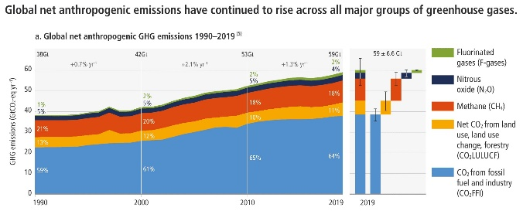
Source: IPCC Sixth Assessment Report Summary: Mitigation of Climate Change

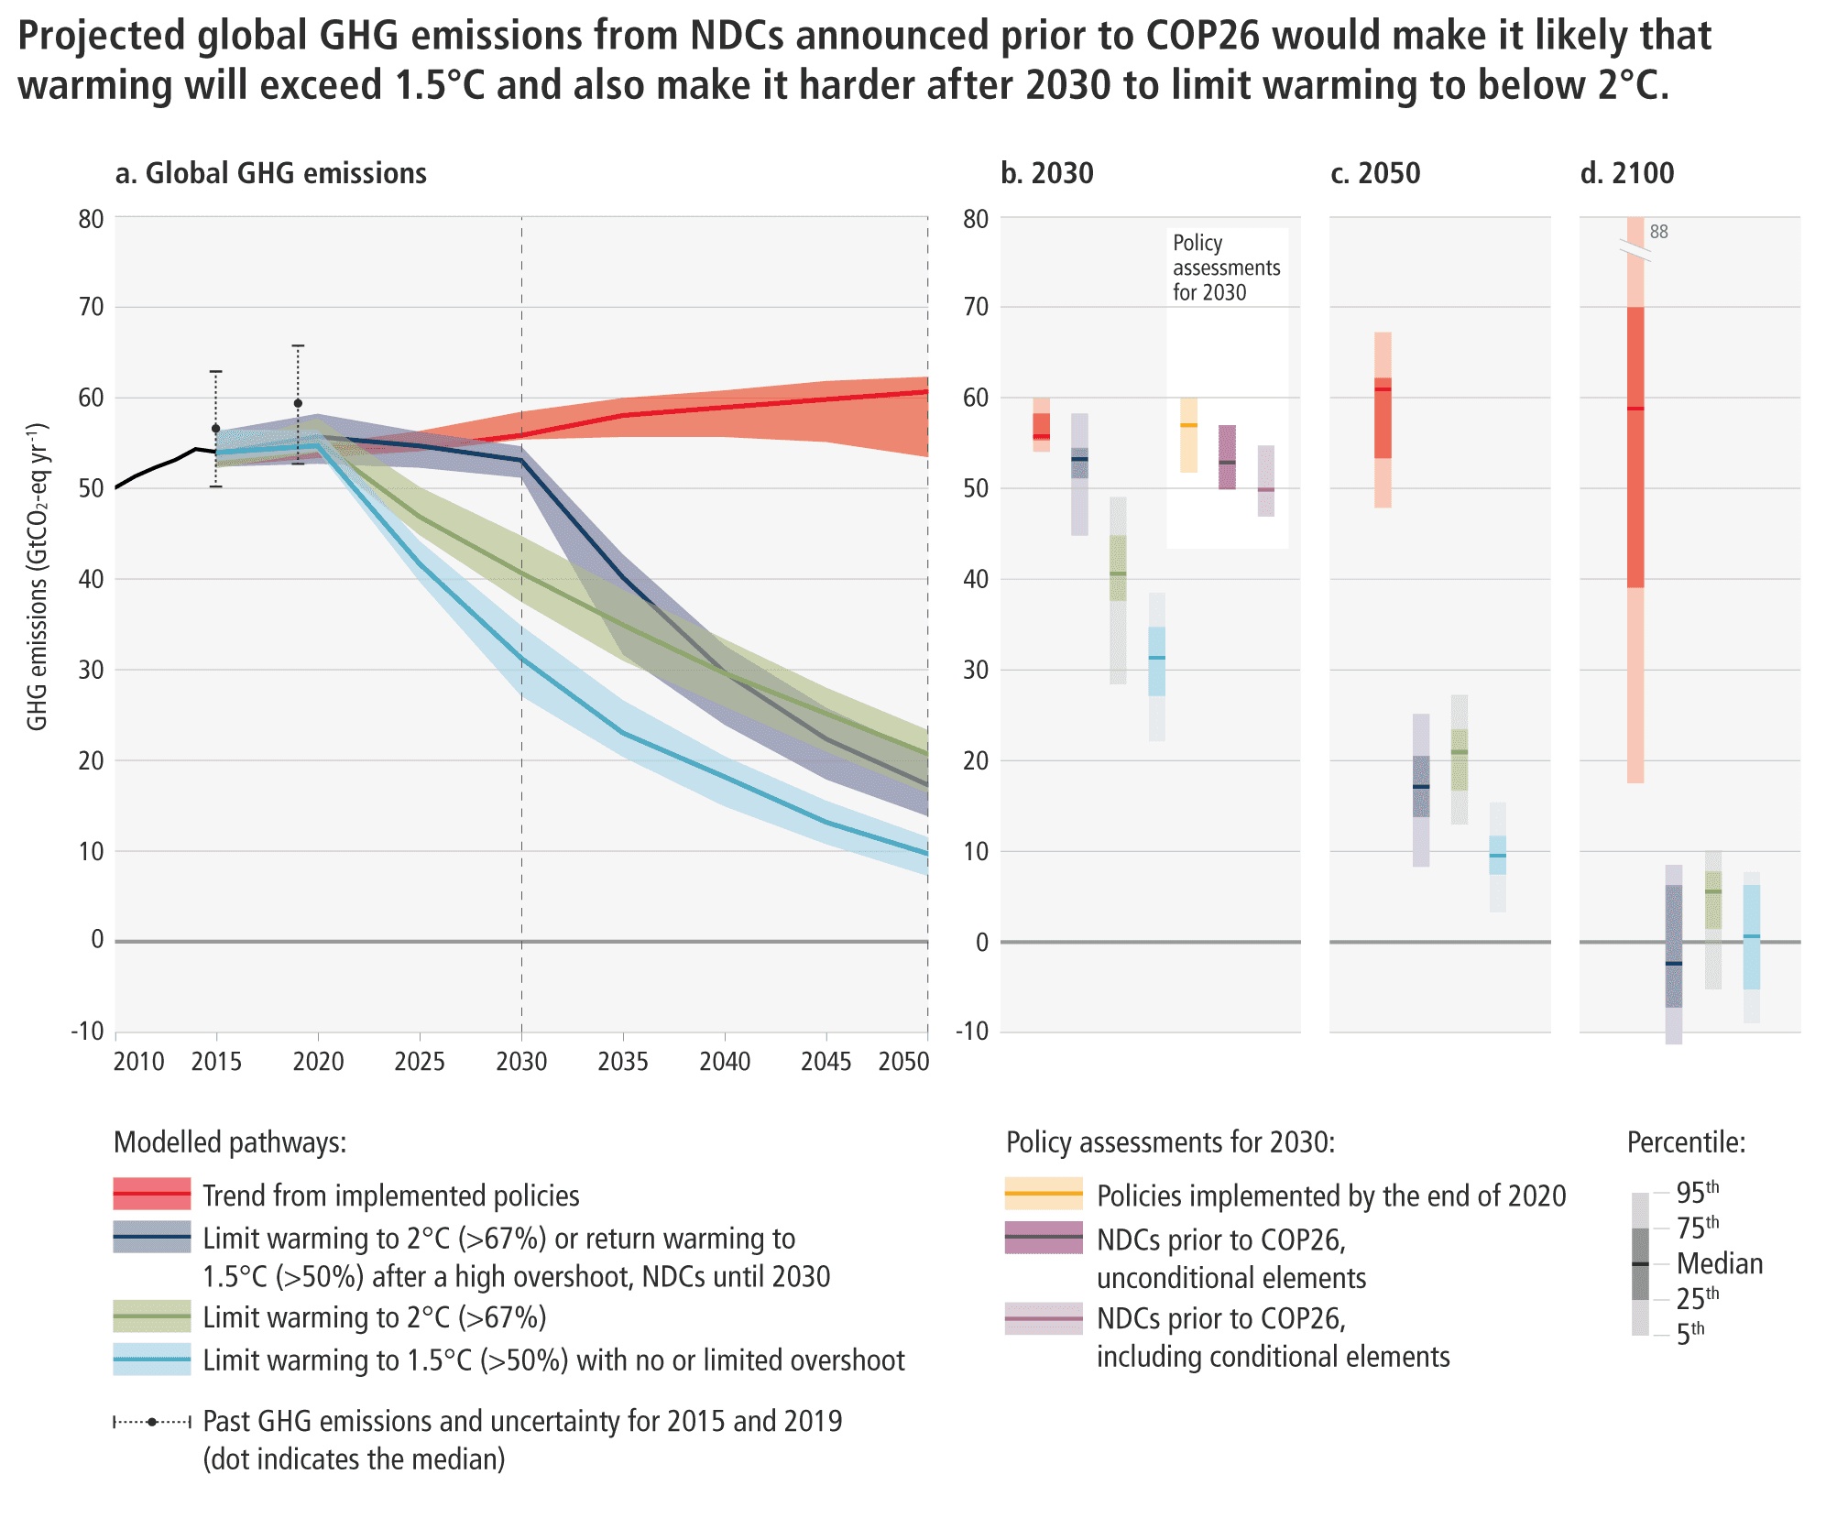
Source: IPCC Sixth Assessment Report Summary: Mitigation of Climate Change

