


FX Week Ahead
Thursday 31st March 2022

Hunt for gas revives Africa exploration
As Russia’s war in Ukraine drives European countries to seek alternative sources of gas, the long-delayed Tanzania LNG project is being revived, with talks between the government and companies led by Equinor and Shell expected to conclude by June, President Samia Suluhu Hassan told Bloomberg this week. Tanzania expects an initial $10bn of investment for the project, which stalled under former President John Magufuli. Neighbouring Mozambique’s auction of oil and gas exploration blocks is also receiving interest from companies, according to Bloomberg. Meanwhile, the African Development Bank is creating a $1bn emergency food production plan in a bid to avert food shortages, with AfDB President Akinwumi Adesina warning that the conflict in Ukraine could spark a crisis for Africa.

Naira heads for new low amid calls for CBN supplies
The Naira was under renewed pressure against the dollar this week, briefly retesting its record low of 587 before recovering slightly to 586. Lingering FX scarcity has prompted the Association of Bureaux de Change Operators of Nigeria (ABCON) to call on the country’s central bank to reinstate dollar sales to the unofficial market, eight months after the bank halted FX sales to bureau de change operators. Meantime, port clearing agents threatened to strike again if the Nigerian Customs Service refuses to review increased duty prices for imported vehicles. Clearing agents ended their previous strike after the customs service suspended a new vehicle identification system for one month to clear the backlog of vehicles stuck at the ports. Given the persistent scarcity of FX, we expect the Naira to weaken beyond the 587 low in the coming days.
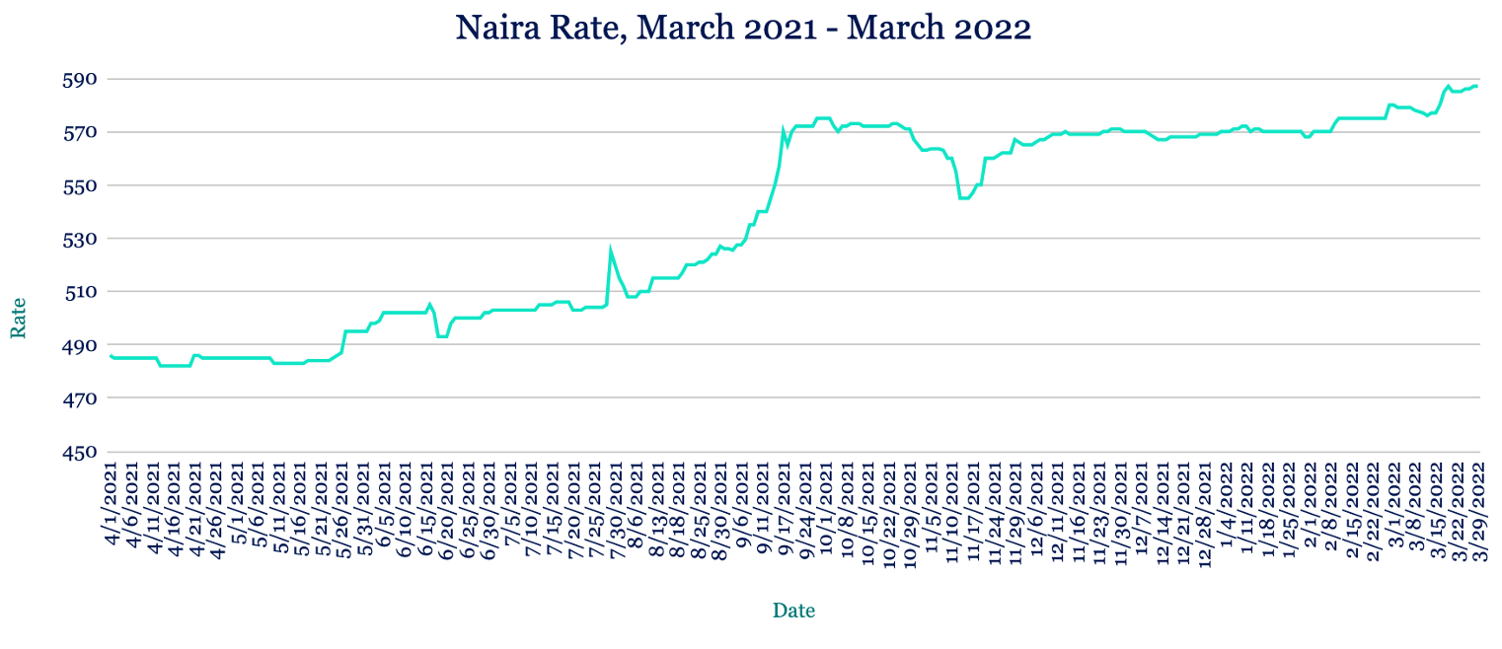
Cedi hits record low as Ghana passes controversial E-levy bill
The Cedi continued its decline against the dollar, weakening to a fresh low of 7.57 from 7.48 at last week’s close. The Central Bank of Ghana has been seeking to prevent a steeper decline through its bi-weekly FX forward auctions, pumping $450m of FX into the market during the first quarter. Amid soaring inflation sparked by the coronavirus pandemic and rising commodity prices as a result of Russia’s war in Ukraine, Ghana’s cash-strapped government this week passed its controversial E-levy bill. The bill will impose a 1.5% tax on electronic transfers and transactions, and is expected to raise the government around $900m in revenue. We expect the Cedi to extend is losses in the coming days given its exposure to global events.
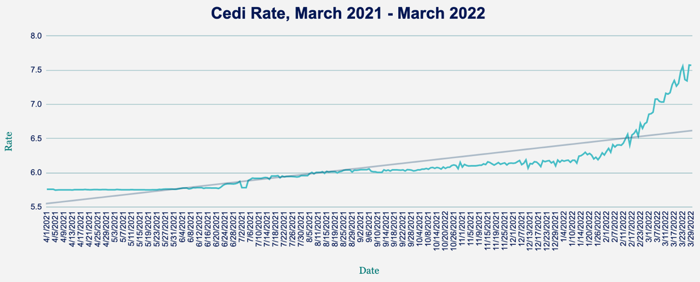
Rand rally to five-month high risks reversing
The Rand strengthened to a roughly five-month high against the dollar, trading at 14.48 compared to 14.55 at last week’s close as risk appetite improved amid signs of progress in Russia-Ukraine peace talks. Expectations that the South African Reserve Bank will continue tightening monetary policy following its 0.25% hike last week, coupled with a better economic outlook, also helped boost the Rand. However, prospects of a more hawkish US Federal Reserve and concerns over the impact of fresh lockdowns in China capped any further gains. Given those latter worries, we expect the Rand will come under renewed pressure in the near term.
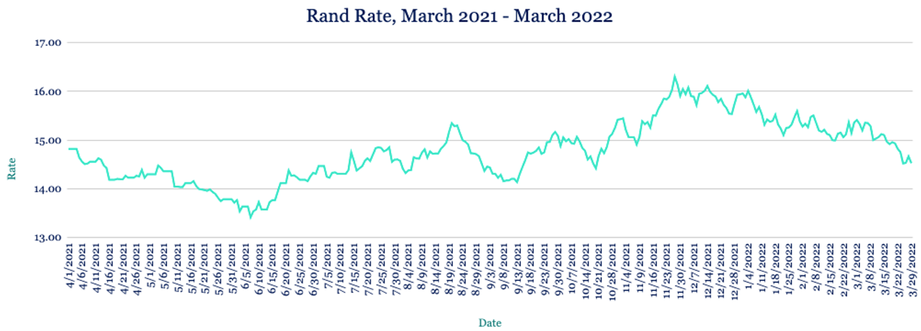

Devalued Egyptian Pound climbs higher amid wheat talks
The Pound appreciated against the dollar this week, trading at 18.23 from 18.54 at last week’s close as the currency rebounds following a deliberate 14% devaluation to mitigate the economic impacts of Russia’s war in Ukraine. Egypt has turned to France and India to source alternative wheat supplies given its past reliance on Russian and Ukrainian grain imports. The country is in talks to secure as much as 12 million tons of wheat from India. The government also this week launched an electronic receipt system to help improve tax collection on goods and services and widen its tax reach to include unrecorded economic activities. The new system will allow the government to monitor transactions in real time. Given Egypt’s proactive fiscal policy adjustments, we expect the Pound to stabilise around 18.30 levels in coming days.

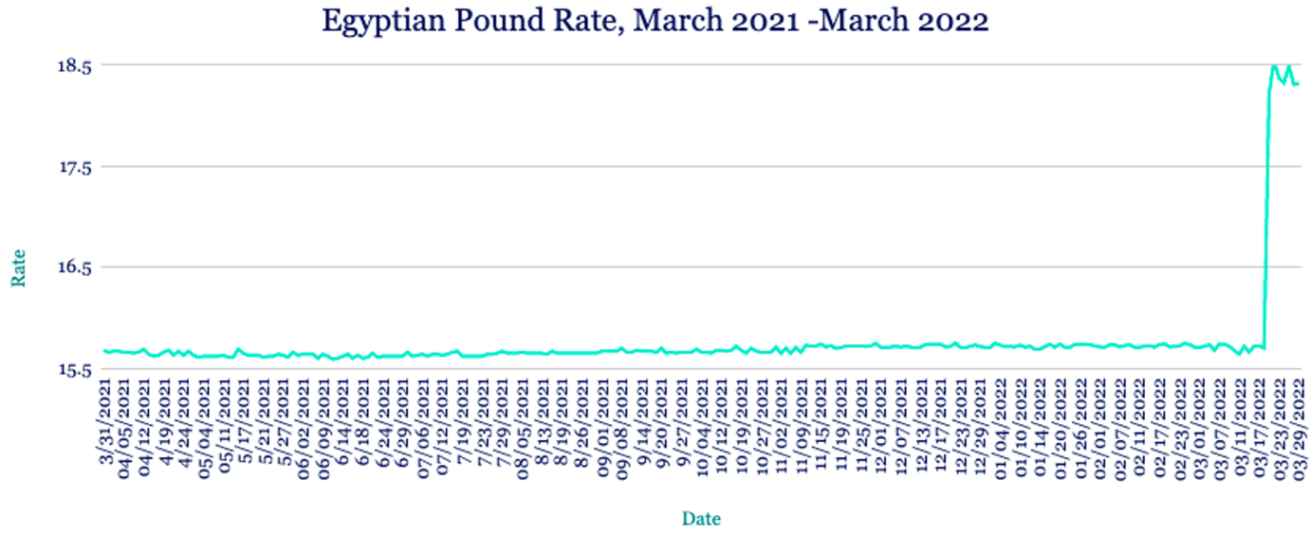

Kenyan Shilling at new low on commodity importer FX demand
The Shilling stumbled to a fresh low against the dollar this week, hitting 115 levels amid extremely high demand for the greenback from energy and commodity importers, particularly for food. Dollar supply from traditional sources remains flat given exports continue to suffer due to the conflict in Ukraine, with tea exports to Russia halted completely. Kenya’s central bank this week maintained its base lending rate at 7% for the 13th time in a row, noting that inflation was within its target range. We expect the Shilling to weaken further in coming days.

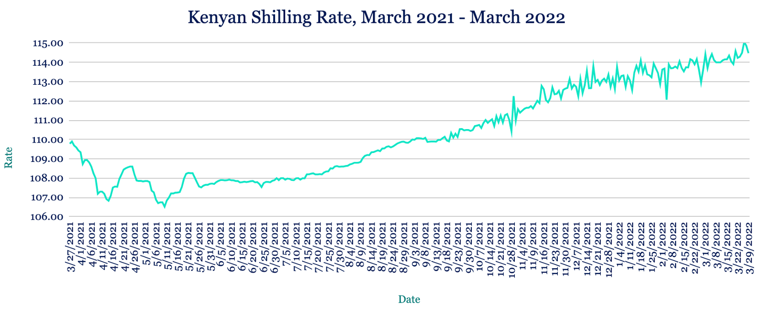
Returning bond investors to boost Ugandan Shilling
The Shilling appreciated against the greenback this week, trading at 3590/3600 from 3610/3620 at last week’s close amid lower dollar demand from energy importers and an uptick in month-end supply from NGOs and coffee exporters. With global risk sentiment improving on hopes of a breakthrough in peace talks between Russia and Ukraine, we expect the Shilling to strengthen further as offshore investors return to Uganda’s bond markets.

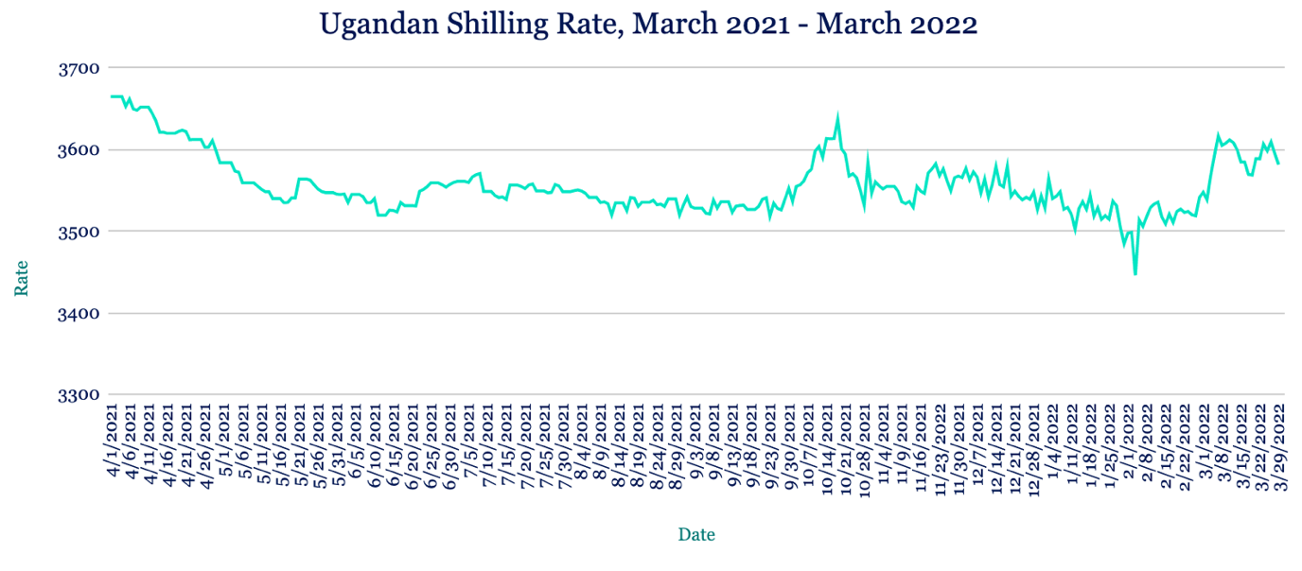

Higher gold prices to bolster Tanzanian Shilling
The Shilling depreciated marginally against the dollar this week, trading at 2316/2326 from 2315/2325 at last week’s close. A spike in energy prices is expected to weigh on Tanzania’s inflation rate, which is currently under 3.5%. The country’s central bank has pledged to continue supporting the economy through the post-Covid period and said it will take appropriate measures to cushion against any impacts from Russia’s war in Ukraine. The World Bank has also promised to give support to various projects in the country, especially in the energy sector. We expect the Shilling to strengthen in the coming weeks, supported by higher gold prices and inbound investments.

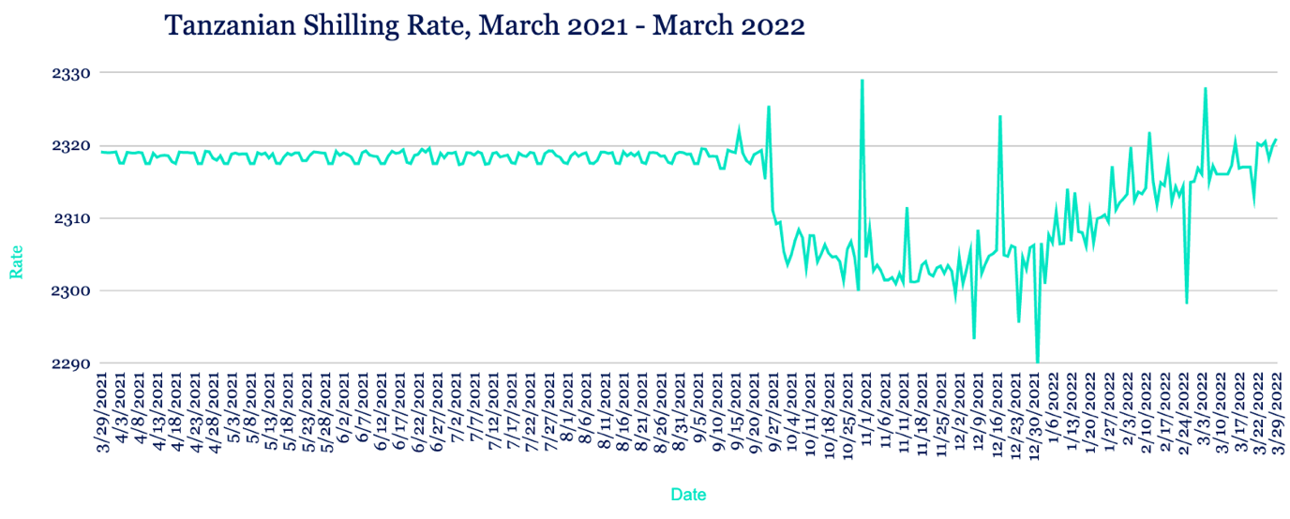

Note to journalists: please feel free to quote from this briefing for news reports and let us know any requests for further comment or interviews via the contact details at the end, or by reply to this email. AZA is Africa’s largest non-bank currency broker by trading volume at over $1 billion annually. See https://www.azafinance.com
Issued by AZA. This Newsletter is produced as a service to our clients. It is prepared by our dealing professionals and is based on their understanding and interpretation of market events. AZA cannot be held responsible for any losses of whatever nature sustained as a result of action taken based on comments contained in this publication.

For more information, high-resolution charts or interviews, please contact:
Gavin Serkin
gserkin@newmarkets.media
+44 20 3478 9710

