FX Week Ahead
Thursday 17th March 2022

Africa oil currencies diverge as Kwanza tops Dinar, Naira
The oil price spike following Russia’s invasion of Ukraine has had divergent effects on the currencies of Africa’s major oil producers. Angola—Africa’s third largest oil producer—has seen its currency, the Kwanza, jump nearly 15% against the dollar in the past month, making it the world’s best performing currency. By contrast, Libya—the second largest producer—has seen the Dinar drop by 1.7% over the same period. In part, that is because the central bank has been buying dollars, but also because oil output has declined after militias shut down two oil fields, including the country’s largest, Sharara. In Nigeria—Africa’s biggest oil producer—the Naira has appreciated only marginally from a record low in the unofficial market. Since the Central Bank of Nigeria stopped FX sales to the country’s Bureau de Change outlets last July, the potential uplift from higher crude export revenue on CBN reserves no longer feeds through to the unofficial rate, which is now solely a reflection of dollar demand and supply. The impact on the real economy is more mixed: Nigeria exports crude oil but it imports the refined product for fuel, creating higher import prices that risk accelerating inflation. Overall, the drop in oil prices to below $100 a barrel this week from $123 earlier this month will help ease FX pressure for most of Africa, particularly in the biggest net importer countries, such as Kenya.

Nigeria inflation ticks higher while oil output slows
The Naira appreciated marginally against the dollar on the unofficial market this week, trading at 576.5 from 577 at last week’s close, still within striking distance of the record low of 580. Nigeria’s crude production fell in February to 1.417 million barrels per day from 1.427 million a month earlier, crimping FX inflows. Rising gas and liquid fuel prices caused inflation to accelerate to 15.7% last month from 15.6% in January. We expect the Naira to remain around these levels in the near term.
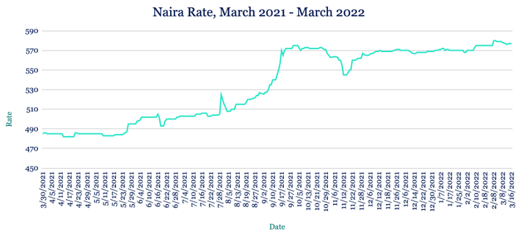
Cedi tumbles to record as bond auction falls short
The Cedi hit a fresh record low against the dollar this week, trading at 7.159 from 7.084 at last week’s close. Ghana’s challenging economic backdrop, which saw inflation rise to an almost six-year high of 15.7% in February, left the Bank of Ghana unable to sell as many bonds as planned at its five-year debt auction at the end of last week. Investors bought GHS862m of the GHS1bn on offer, with an interest rate of 20.75%—the higher end of price guidance. We expect the pressure on the Cedi to continue over the coming week.

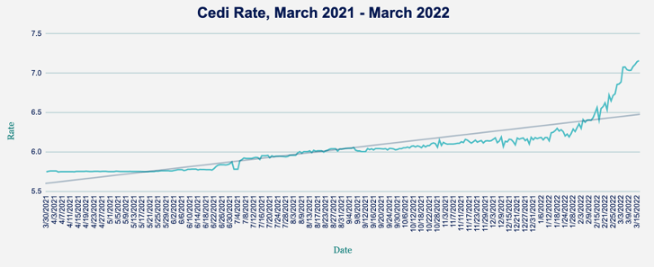
Stronger Rand subject to Fed hike reaction
The Rand strengthened against the dollar this week, appreciating to 14.99 from 15.05 at last week’s close as South Africa’s economy recovered faster than expected from the impacts of the pandemic and amid stronger commodity prices. The US Federal Reserve raised its interest rate this week by 0.25%, pushing its target range to between 0.25% and 0.5%—the first increase since 2018, in-line with market expectations. The Fed also projected that it expects rates to rise to almost 2% by the end of this year—a percentage point higher than predicted back in December. How the market digests the pace of Fed tightening will dictate the direction for the Rand against the dollar in the coming days.
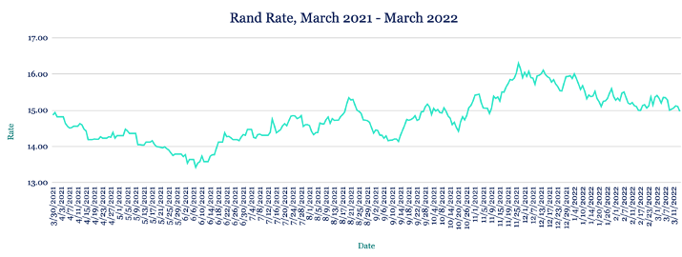

Fastest growth this century points to Egypt rate rise
The Pound was steady against the dollar this week at 15.71. Egypt’s economy experienced its fastest six-month growth rate since the turn of the century, expanding by 9% between July and December 2021. However, the impact of Russia’s war in Ukraine, particularly on global wheat prices, is likely to dent the country’s economic outlook. Fitch Ratings says Egypt could raise interest rates next week and may need to seek further IMF support to mitigate the impacts of the war, creating uncertainty for the Pound. However, a deal between Egypt and the Saudi Public Investment Fund this week is likely to help keep the currency steady in the near term.
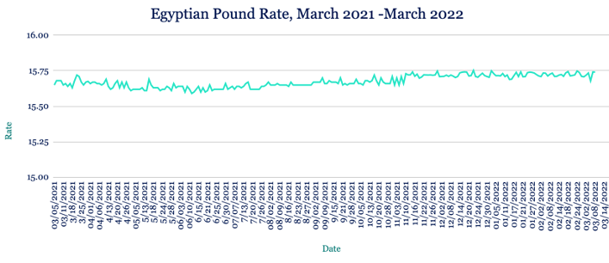

Kenyan deficit widens as Shilling hits new low
The Shilling continued to weaken against the dollar, hitting a fresh record low of 114.40/115 this week from 114.15 at last week’s close as dollar demand from oil importers was unmet by FX inflows from agriculture exports and remittances. The Shilling’s weakness has widened the country’s balance of payments deficit to an estimated 5.6% of GDP in January, compared to 4.3% a year earlier. Kenya has been seeking to boost trade ties with Saudi Arabia and Oman, with officials from both countries meeting with Kenya this week to discuss trade and investment opportunities. Meantime, the country’s FX reserves rose to $8bn from $7.9bn a week earlier. With higher fuel and commodity prices increasing the cost of living, we expect the pressure on the Shilling to continue over the coming week.
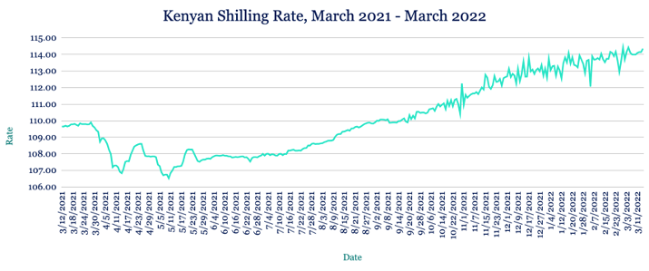
Recovery for Ugandan Shilling unlikely to hold
The Shilling recovered ground against the dollar this week, appreciating to 3580/3590 from 3610/3620 at last week’s close. That strengthening was supported by increased inflows from commodity exporters and non-governmental organisations, which outweighed importer demand for the dollar. Looking ahead, we expect commodity supply constraints to feed inflationary pressures, with the Shilling coming under renewed strain in the short term.

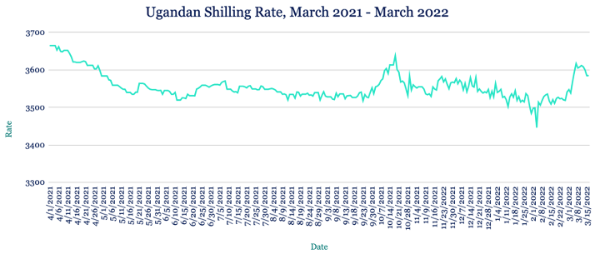

Tanzanian-Kenya agreement on trade barriers
The Shilling weakened slightly against the dollar this week, slipping to 2312/2322 from 2311/2321 at last week’s close. Tanzania and Kenya agreed to remove additional trade barriers, including resolving delays in issuing import permits for dairy products, delays in goods clearances and easing other cumbersome procedures. An easing of trade restrictions between the two countries will help boost economic growth and improve liquidity conditions in Tanzania. We expect the Shilling to be stable over the coming week with support from agricultural exports.

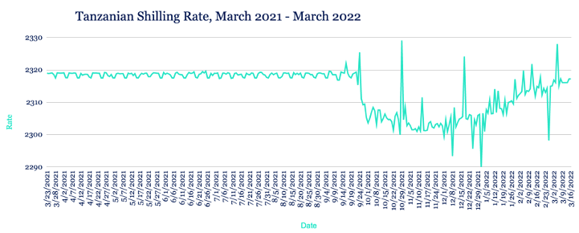
Note to journalists: please feel free to quote from this briefing for news reports and let us know any requests for further comment or interviews via the contact details at the end, or by reply to this email. AZA is Africa’s largest non-bank currency broker by trading volume at over $1 billion annually. See https://www.azafinance.com
Issued by AZA. This Newsletter is produced as a service to our clients. It is prepared by our dealing professionals and is based on their understanding and interpretation of market events. AZA cannot be held responsible for any losses of whatever nature sustained as a result of action taken based on comments contained in this publication.

For more information, high-resolution charts or interviews, please contact:
Gavin Serkin
gserkin@newmarkets.media
+44 20 3478 9710

