FX Week Ahead
Thursday 3rd March 2022

Russia trade war puts African gas in focus
As Vladimir Putin’s war in Ukraine continues to intensify and Western sanctions on Russia mount, so the likelihood increases of Moscow retaliating by shutting off its gas supply to European markets. Such risk is focusing attention on alternative gas producers, notably in Africa. Nigeria, which already supplies liquified natural gas (LNG) to Europe, last month signed an agreement with Niger and Algeria to build a Trans-Saharan Gas Pipeline. Estimated to cost around $13 billion, it is expected to supply 30 billion cubic metres of natural gas a year and connect with pipelines into Europe. Meanwhile Senegal is set to begin production this year after discovery of 40 trillion cubic feet of natural gas. As mentioned in our report last week, President Samia Suluhu Hassan has noted increased interest in Tanzania’s gas reserves as a result of Russia tensions. Prospects for gas exports to Europe have been given a boost longer term by the European Union’s decision last month to include natural gas as a “green” energy source in the transition to renewables. Other commodity producers likely to see increased uptake as a result of the geopolitical tensions include South Africa, which is the world’s second biggest producer of palladium after Russia.

Naira slides to record as election spending kicks off
The Naira slumped to a record low against the dollar on the unofficial market this week, depreciating to 580 before recovering slightly to 579. Dollar demand is rising as political spending kicks off ahead of Presidential and National Assembly polls, with party primaries to nominate candidates scheduled between April 4 and June 3 this year. The surging price of oil—Nigeria’s biggest export earner—has less effect nowadays in the parallel market since the Central Bank of Nigeria cut off intervention in the unofficial market. Meanwhile, chaos ensues at the country’s ports, where a dispute between the Nigerian Customs Service and striking clearing agents over the implementation of a new vehicle valuation system entered a second week with talks ending in deadlock. Congestion is mounting as more new vehicles arrive, with consequent knock-on economic impacts the longer the protests continue. Clearing agents say the new system has drastically increased import duties, making it challenging to clear vehicles from the ports. Separately, as part of its longer term FX strategy, the CBN announced a rebate scheme to raise $200bn in earnings from non-oil proceeds over the next three-to-five years by incentivising exporters to repatriate and then sell dollars into the local market. We expect the Naira to hold temporarily at the weaker end of the 570’s range as election spending ramps up.
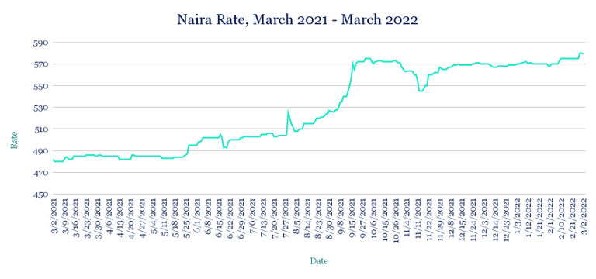
Cedi tumbles to record as borrowing costs climb
The Cedi plunged to a new low, sliding 1.8% to 6.87 per dollar from 6.75 at last Friday’s close, amid sustained high demand for FX and strains on supply. Interest rates on Ghana’s short-term local debt rose again this week, with the 91-day and six-month treasury bills both climbing 3bps to 12.91% and 13.29%, respectively. Higher borrowing costs will likely continue deterring private investment into the economy, driving up demand for imports, which will continue weighing on the Cedi. With that in mind, we expect the pressure on the Cedi to remain elevated in the near term.
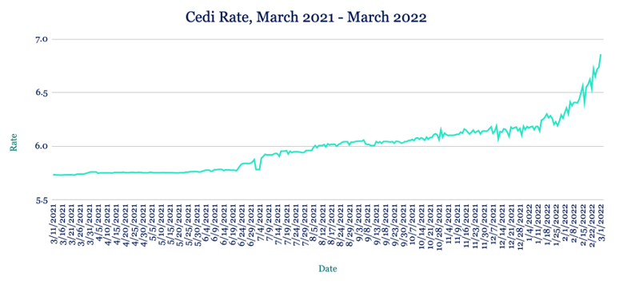
Risk-off sentiment rattles Rand
The Rand weakened against the dollar this week, trading at 15.47 from 15.14 at last Friday’s close as Russia’s war in Ukraine drove investors out of emerging markets to assets deemed safer. Despite the ongoing uncertainty in Ukraine and the likelihood of more volatility in the coming days, we expect broader risk appetite to return, with the Rand strengthening by the end of the quarter.
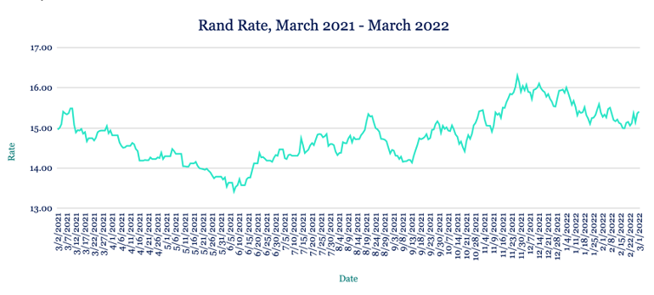
Egyptian Pound bounces back from 2-month low
The Pound appreciated against the dollar this week, trading at 15.71 having last week slid to 15.75—the weakest level since the start of the year. With Russia’s war in Ukraine driving up global wheat prices, Egypt cancelled two wheat tenders and increased the target of local wheat purchases to 5.5mn tons for the upcoming season from an initial target of 4mn. An increase in global trade also saw the Suez Canal Authority raise transit tolls by 10% this week, barely a month after lifting by 6%. We expect the Pound to remain below 15.75 in the coming weeks.
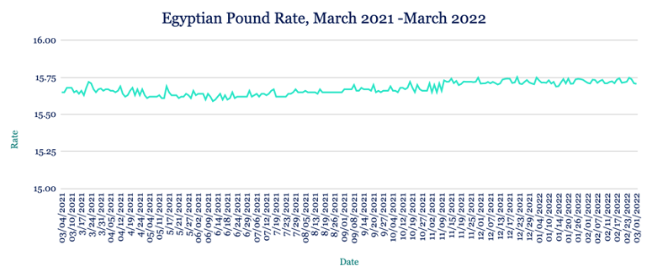

Rising food costs push Kenyan Shilling to new low
The Shilling hit a fresh record low against the dollar this week, sliding to 113.85/114.45 from 113.7 at last week’s close as Russia’s war in Ukraine increased demand for haven assets, strengthening the US currency. The conflict has also impacted imports, with the prices of food such as wheat rising, which has resulted in more dollar demand and further weakened the Shilling. Central bank reserves rose slightly to $8.130bn from $8.125bn the previous week, adequate for 4.97 months of import cover. Given intervention from the central bank to shield the Shilling from volatilility, we expect the currency to stabilise at current levels near term.
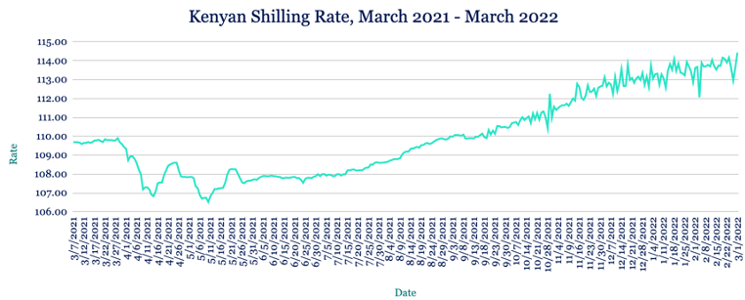
Higher import costs weaken Ugandan Shilling
The Shilling depreciated against the dollar this week, trading at 3540/3550 from 3520/3530 at last week’s close as a result of month-end importer demand that outweighed inflows from exports and remittances. Inflation rose in February to 3.2% from 2.7% a month earlier amid the rising cost of education. The broader increase in consumer prices comes as economic activity ramps up following the removal of almost all pandemic measures and the reopening of the hospitality and education sectors. Given higher import prices on goods such as wheat and other grains following Russia’s invasion of Ukraine, we expect to see more inflation and therefore sustained pressure on the Shilling in the near term.
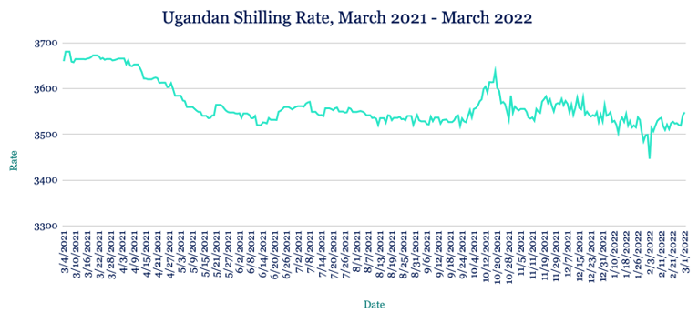
Tanzania risk of debt distress rises to moderate
The Shilling was unchanged against the dollar this week, trading at 2310/2320. The World Bank this week said Tanzania’s risk of debt distress has increased from low to moderate, in part because of the impact Covid-19 has had on the country’s tourism sector. To ease the risk of distress, the bank urged Tanzania to focus on projects that promise clear socio-economic payoffs, balancing emergency spending with the broader development agenda. The bank forecasts Tanzania’s economy will expand between 4.5% and 5.5% this year, up from 4.3% in 2021. We expect the Shilling to weaken slightly in the week ahead amid increased demand from importers and reduced support from inflows.
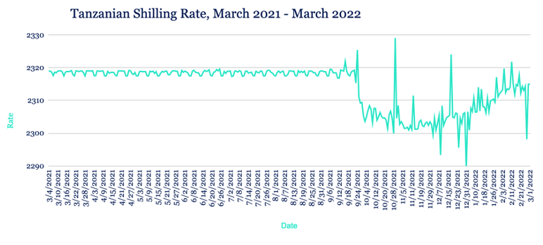
Note to journalists: please feel free to quote from this briefing for news reports and let us know any requests for further comment or interviews via the contact details at the end, or by reply to this email. AZA is Africa’s largest non-bank currency broker by trading volume at over $1 billion annually. See https://www.azafinance.com
Issued by AZA. This Newsletter is produced as a service to our clients. It is prepared by our dealing professionals and is based on their understanding and interpretation of market events. AZA cannot be held responsible for any losses of whatever nature sustained as a result of action taken based on comments contained in this publication.

For more information, high-resolution charts or interviews, please contact:
Gavin Serkin
gserkin@newmarkets.media
+44 20 3478 9710

