



Background

Key Messages

A largest percentage of e-waste in Ghana is managed by the informal sector. While these activities generate value and provide livelihoods for the many workers, they also have an adverse effect on public health and the environment. Fundamental changes are therefore necessary and these changes must systematically address the informal sector.

The Government of Ghana thus passed the Hazardous and Electronic Waste Control and Management Act, 917, the Legal Instrument (LI) 2250 and the Technical Guidelines in 2016 and 2018 respectively. Within the legal framework, informal workers are required to formalise by registering with state authorities and operate under the stipulations of the regulation (EPA and SRI). The requirements vary in accordance with the performed activities, i.e. collection, aggregation, dismantling, recycling and final disposal. While there is consensus that sound e-waste management solutions must address and include the informal sector, practical inclusive strategies on formalisation in Ghana are scarce and there is no overarching, uniform approach for how formalisation of Ghana’s informal e-waste workforce will take place in practical terms. Some scholars have argued that the pursuit of an entirely single formal managed system may be misdirected, as such a system is atypical in Ghana’s e-waste economy. Consequently, a more appropriate approach would include an integrative framing of a formal/informal sector in a continuum, that aims to alleviate the most significant existing drawbacks of the informal sector (Oteng-Ababio & Grant 2021).

Progressing formalisation in the e-waste sector is one of the key aspects of the new e-waste legislation in Ghana. For this purpose, sustainable integrative approaches are needed, that adequately addresses environment, health and safety aspects and ensure a level playing field for informal and formal actors in the e-waste value chain.

Based on the “Trust be Key” report by the E-MAGIN Consortium, this policy brief offers a set of recommendations for practical measures towards formalisation for the e-waste value chain. The key takeaways include:

Expand relationships with scrap dealer associations

Provide financial and technical support to accelerate formalisation for scrap dealer associations

Make use of adequate agreements that reflect the socio-economic needs and constraints

Encourage non-monetary incentives as complementary instruments to establish long-term, trustworthy partnerships

Offer financial incentives in order to ensure a steady influx of e-waste from collectors

E-MAGIN GHANA

E-Waste Management in Ghana

Pathways to formalisation in Ghana’s E-waste Sector – a policy brief on sustainable approaches to formalisation

In order to promote the valuable work of the associations, there is a clear need to support them in administrative activities such as documenting their activities, registering their members, opening and maintaining bank accounts, organising regular meetings with all members or issuing identity cards to their members.

Targeted trainings could furthermore help associations to understand the legal requirements of Act 917, LI 2250 and the practical implementation of the Technical Guidelines. Provision of land in coordination with other relevant authorities could also be an approach to support associations. This way, well-organised and registered associations can operate safely and under scrutiny of the rule of law. Additionally, MMDAs need to recognise the operations of associations at the local level by openly engaging with them, simplifying business registration and creating opportunity spaces for formalised activities. The diagram on the next page displays a payment scheme analysed within the “Trust be key” report, which showcases the potential of interlinkages of different e-waste stakeholders and e-waste associations. The diagram sorts stakeholders according to the typology proposed within the “Trust be key” report.

The payment scheme was implemented within the Old Fadama Scrap Yard and focused on cables as the main choice of materials. The pilot was mainly carried out by the German Öko-Institut in close collaboration with the local NGO GreenAd, which owns a container-based structure in the scrap market (known as the Agbogbloshie Recycling Center). GreenAd was responsible for local market surveys, purchasing test batches of cables, upgrading of the physical infrastructure and the on-ground implementation of the pilot (incl. running the handover centre, accepting and compensating cables at previously defined conditions as well as managing the incentive budget). Local support was provided by the Greater Accra Scrap Dealers Association (GASDA) to facilitate collection of e-waste through their channels.

For instance, some recyclers have successfully established partnerships by offering contributions to pension funds or health insurance (e.g. City Waste Recycling). Others have decided to provide advance payments that, although perceived as risky, create the opportunity for collectors to acquire larger amounts of e-waste than usual.

Developing a coherent policy strategy is essential to align targeted efforts along the current shortcomings of the e-waste sector and address the lack of skill development opportunities for workers in informal and rural economies. Furthermore, it could induce a change of current gender inequalities present in the e-waste sector and could help to empower women to attain the required e-waste management qualifications.

offer support for their professionalization

A particular deficiency exists in the administrative activities and sufficient technical and legal know-how of the associations, which in turn often leads to legal and transactional uncertainties. To be recognized as competent business partners, associations themselves need to prove sound competencies within administrative operations.

Based on the “Trust be Key” report published by the E-MAGIN Consortium in early 2021, which explored pathways to formalisation in Ghana’s e-waste sector, this policy brief offers a set of recommendations for approaches to advance formalisation in Ghana's e-waste sector and develop an integrated policy framework. To this end, the findings of the report have been complemented and combined with new insights from the literature.

From the analysis a set of recommendations was developed that cover the most crucial aspects of progressing formalisation in the e-waste sector.

Expand relationships with scrap dealer associations

A central role in the formalisation of the sector is that of the scrap dealers' associations. In fact, they have already proven to be a useful vehicle for formalising the activities of informal workers, as they established partnerships with formal recycling industries. As such, they act as valuable intermediaries for contact and cooperation between formal waste management companies such as Blancomet, Fidev and Presank and actors in the informal sector. Maintaining and nurturing these relationships with scrap dealers' associations helps formal recyclers to ensure a steady inflow of material and to expand their collection networks. However, the lack of resources and the loose nature of existing associations in Ghana suggest that they are currently limited in their ability to link informal and formal actors in a truly effective way.

Designing Effective Measures

Methodology

E-MAGIN GHANA

E-Waste Management in Ghana

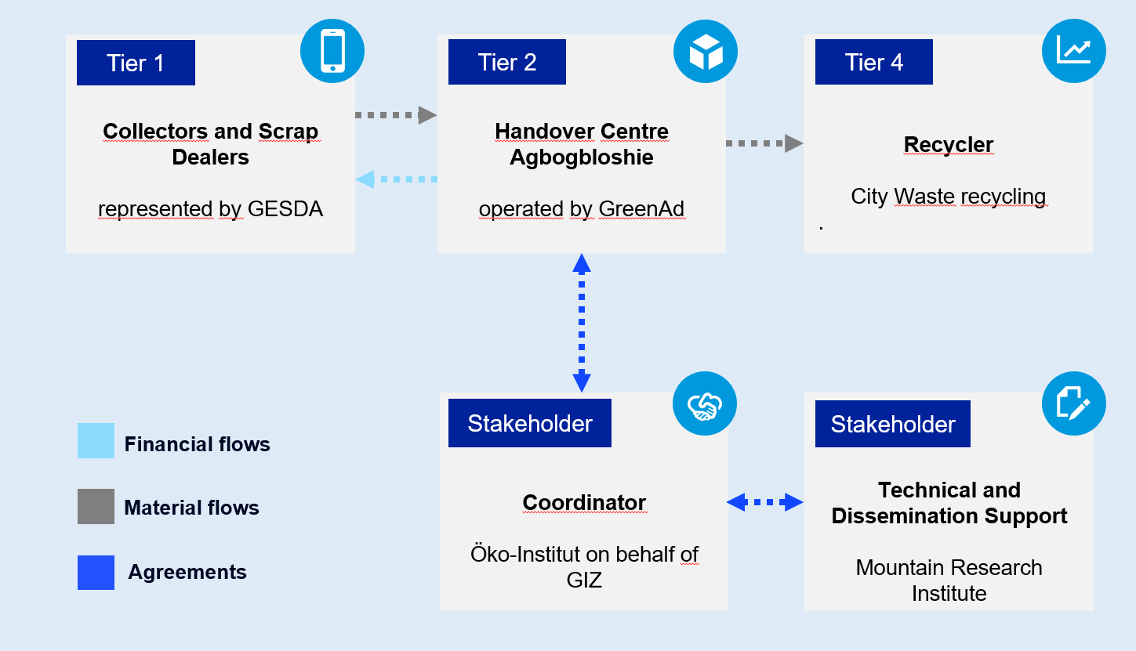

**Figure 1: Tiers and relationships for different actors set out in the MESTI-GIZ pilot payment scheme**

Other useful incentives may be provided in the form of equipment, protective gear for collectors or groups of collectors, ID cards and uniforms that create public recognition as official service workers and technical assistance for filing tax returns or other legal requirements. Collectors may also benefit from advocacy activities to promote their rights as e-waste workers and certificates or other forms of compliance verification which protect collectors from unjustified legal prosecution.

Encourage non-monetary incentives as complementary instruments

Beyond financial incentives, several other non-monetary incentives can motivate the formation of formal-informal partnerships and can offer value to collectors or scrap dealer associations. Non-financial incentives can be provided by public authorities but are more likely to be provided by stakeholders from the private sector. In the case of recellGhana and Atlantic Recycling, non-monetary incentives are offered in form of trainings on collection, dismantling and business development. Such trainings can significantly reduce the risks of work place injuries and pollution. As mentioned before, non-financial incentives may also include access to public or private services, technical support to formalise as an individual or a group (i.e. forming an association of scrap workers or acquiring tax identification numbers) and access financial services.

Regular payments of fixed salaries (per week or month) can be offered instead of payment per delivery. This allows for a reliable income, even if the overall payment might be lower (Hinchliffe et al. 2020). Clear pricing mechanisms and transparent reporting requirements can help to overcome challenges in collaborating with collectors.

Offer financial incentives to ensure a steady influx of e-waste from collectors

Since informal recycling is mostly more cost-effective compared to formal recycling, formal recyclers report that accessing sufficient amounts of e-waste can be challenging. Till date, the single largest incentive for collectors to channel e-waste towards informal or formal recycling channels in Ghana are financial returns. While the gap between formal and informal prices cannot be bridged by formal recyclers alone and will be addressed by the gradual implementation of Act 917, formal recyclers should consider offering alternative monetary incentives that make it attractive to informal collectors to enter long-term partnerships. Depending on the recycling process and the stakeholders different options may be considered. (e.g. by assisting in opening of a bank account, mobile money accounts or insurances).

**create a level playing field**

A key barrier to formalisation of informal collection and recycling activities in Ghana is the prevailing price delta of informal transactions vis-à-vis formal transactions. At its core, the primary cause is that informal recyclers tend to compete at the neglect of environment, health and safety conditions and thus externalise costs to the general public. To the extent possible, it is advisable to focus on the most polluting operations of the e-waste value chain first. One of more visible ill-practices include the open burning of cables, for which remarkable progress has been achieved already. Yet, less visible but equally polluting activities (e.g. inadequate disposal of lead acid batteries, crushing of CRT screens) continue to thrive. Further support is needed for formal collectors and recyclers that want to export collected materials that cannot be recycled in Ghana. Business operations are often hindered or interrupted due to export restrictions that require more enforcement to reduce bureaucracy for the authorisation of export permits.

Research conducted as part of the Trust be Key report and this policy brief suggests that successful step-wise transformation of the sector can only be achieved when the needs and constraints of relevant actors from the public, private and civil society are addressed. It is clear that scrap dealer associations are crucial vehicles for formalisation that are able to bridge the gap between formal and informal operators. There is a need for associations to further professionalize their business and for support from the government and the formal recyclers. Finally, financial and non-monetary incentives are powerful instruments and should be chosen thoughtfully, tailored to the specific situation, and ideally, combined to achieve desirable effects and accelerate the pace of formalisation in the e-waste sector.

agreements that reflect the socio-economic needs and constraints

Agreements between formal operators and informal actors can take different forms, but lasting partnerships almost always rely on some sort of agreement. For instance, the ESPA tricycle initiative advocates for formalisation and utilizes written agreements to ensure that informal collectors are registered under an association under ESPA. Due to the transactional nature of the partnership – informal collectors can make purchase of tricycle at the price of GHS 9,500 – a written contractual agreement is required. However, some collectors may not possess the financial means nor the ability to sign written agreements due to a lack of formal education. In this case other forms of agreement have to be arranged. Going forward, written agreements are likely to become increasingly important. Individual collectors and dismantlers are encouraged to register and/or form associations. For practical purposes, formal companies will effectively need such formal agreements and MoUs to monitor the activities of associations.

Provision of financial and technical support to accelerate formalisation

Despite a range of individual initiatives that have successfully formalised informal collectors in Ghana, accelerating the pace of formalisation will ultimately depend on the scale of governmental support. Such support can take many forms. For instance, governments can provide access to finance and tax benefits to reward organisations that run environmentally and socially sound operations.

At the central government level however, the disbursement of the e-waste fund established under Act 917 will be crucial in order to bridge the price-gap between formal and informal operations and incentivise collectors to channel e-waste towards authorised recyclers. In regards to the required incentive set-up the aforementioned MESTI-GIZ pilot payment scheme offers valuable insight.

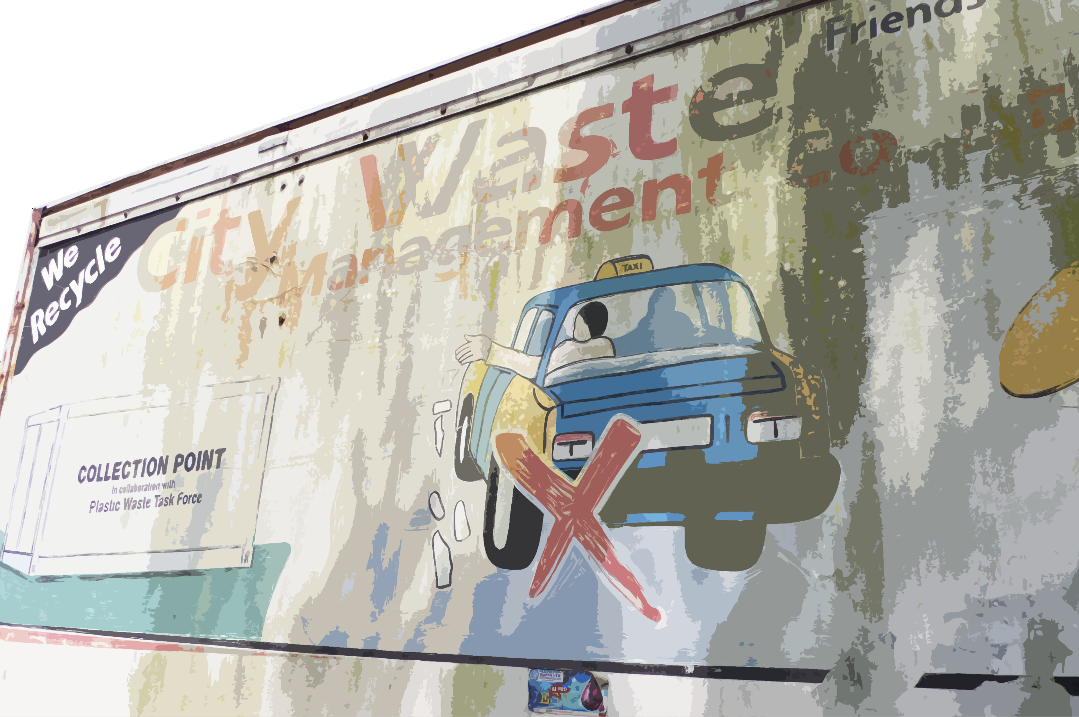

**Conclusion**

**Recommendations**

Grant, Richard & Oteng-Ababio, Martin. (2021). Formalising E-waste in Ghana: An emerging landscape of fragmentation and enduring barriers. Development Southern Africa. 38. 1-14. 10.1080/0376835X.2020.1823822.

Kumi, Ebenezer; Hemkhaus, Morton; Hibler, Sophia; Boateng, Prince; von Falkenhausen, Isabell 2021: Trust be Key. Exploring Pathways to Formalisation in Ghana’s E-Waste Sector. Berlin: adelphi.

All rights reserved. The content of the work created by the E-MAGIN consortium (written by adelphi and reviewed by University of Cape Coast, Ghana National Cleaner Production Centre, City Waste Recycling) and the work itself are subject to German copyright law. Third party contributions are marked as such. Duplication, revision, distribution and any kind of use beyond the limits of copyright require the written consent of the authors or editors. The duplication of parts of the work is only permitted if the source is mentioned. This publication was produced with the financial support of the European Union. Its contents are the sole responsibility of the E-MAGIN consortium and do not necessarily reflect the views of the European Union.

Suggested Citation: Kumi, Ebenezer; Boateng, Prince; Ahlers, Julian; Bauer, Tim 2021: Pathways to formalisation in Ghana’s E-waste Sector – a policy brief on sustainable approaches to formalisation. Accra: E-MAGIN Consortium.

|  |  |
| --- | --- |
| Publisher: | E-MAGIN Ghana [info@e-magin-ghana.com](mailto:info@e-magin-ghana.com) https://e-magin-ghana.com/ |
| Authors: | Ebenezer Kumi; Prince Boateng; Julian Ahlers, Tim Bauer |
| Edited by: | Prof. Rosemond Boohene; Prof. Daniel Agyapong; Daniel Ofori; Matthew Adeyanju; Letitia Nyaaba; Jürgen Meinel; Vivian Ahiayibor |
| Layout: | adelphi research gGmbH |
| Photo credits: | © 2021 adelphi research gGmbH |
|  | |

**Bibliography**

**Imprint**

* **Efforts should focus on an integrative framing of a formal/informal sector in a continuum, that aims to alleviate the most significant existing drawbacks of the informal sector**
* **Scrap dealers' associations should be supported through technical and financial means, as they play a central role in the formalisation of the sector, as previous partnerships have shown already**
* **Such support should address deficiencies in the administrative capabilities and technical and legal know-how of the associations, to avoid legal and transactional uncertainties**
* **Clear pricing mechanisms and transparent reporting requirements can help to overcome challenges in collaborating with collectors**
* **Non-monetary incentives should be set-up to add further value to the formalisation progress and encourage the formation of formal-informal partnerships**
* **Governments can provide access to finance and tax benefits to reward organisations that run environmentally and socially sound operations**
* **Heavily polluting activities have to be sanctioned accordingly to ensure a level playing field**